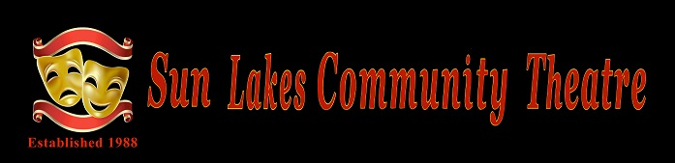
January 2018 Asides

SUN LAKES COMMUNITY THEATRE
GENERAL MEMBERSHIP MEETING FOR JANUARY!!

Hello, theatre friends! Let's get together and welcome the New Year!!!

WHEN: Thursday, January 11, 2018

WHERE: San Tan Ballroom, Cottonwood

TIME: 6:00 pm Happy Half Hour, 6:30 pm meeting

ENTERTAINMENT: Hamilton High School Drama Department

SLCT is proud to make a donation every year to the high school drama departments in Chandler. We are pleased to help support performing arts programs in our area and to help ensure continuing theatre education. Each year we are delighted to be entertained by a different high school drama department on a rotating basis. This year we will enjoy the talents of Hamilton High School's drama students.
NOTES FROM THE BOARD....

The board of Sun Lakes Community Theatre wishes all of you a very happy and healthy New Year. May this year bring about all that you wish for!

It is hard to believe that 2018 is already upon us! We can look back with pride at all the things we have accomplished and look ahead to all of the good things that will be happening in SLCT.

Some of those things: The Spring show, "The TonyLou Awards," has been cast and is gearing up for rehearsals. That show will open on March 20. Our Children's Theatre is working hard and getting ready to perform "Horton Hatches an Egg" for excited children at Chandler elementary schools. The ImproVables, our own improv troupe, will be performing at a dinner show in the IronOaks ballroom on January 5. Merrie Crawford will be teaching Intermediate Acting, beginning on January 20. The Fun Script Reading group will soon get underway. A tech lighting class taught by Norm Harris and MJ Clement is in the works. More fun, interesting, and edifying general membership meetings are coming your way, as well as an end of the year party to look forward to.

And much more!!

Remember that your dues are due this month. They are still only $20. What a bargain, considering all that you gain by being an SLCT member. Reach out and take a class, volunteer to sell tickets and/or usher for a play, work backstage, audition, come to our meetings and be with all of us who love the theatre.

Be sure to join us for our January meeting. We meet as usual in the San Tan Ballroom on January 11. Come at 6:00 pm for the Happy Half Hour and toast the new year with your theatre friends.

You may give your dues to Kathy Jones at that meeting. Make checks payable to Sun Lakes Community Theatre.

See you then!!

Phyllis Novy
President
Holiday Party A Huge Success

On December 12 the fun seekers of the Sun Lakes Community Theatre shared a Holiday meal and entertainment at the Palo Verde Country Club. Santa (Chris Mank) was there to spread good cheer and pose for photos with everyone. After a half hour or so of cocktails and lively conversation we all sat down to a wonderful meal featuring Palo Verde’s famous beef brisket followed by their Chocolate Lava Cake topped with Ice Cream.
Dinner was soon followed by entertainment from musician and vocalist Jared Howe. With encouragement from Kathy Jones people started dancing and that is when the party really took oﬀ. Those that left early missed the best part of the evening. Jared played for over two hours without a break and many of us did not leave until nearly 9:30. Late by Sun Lakes standards. A big THANK YOU goes out to Carol Horowitz, Phyllis Novy, and their helpers for putting together a great Holiday Party.
Jim Janowski

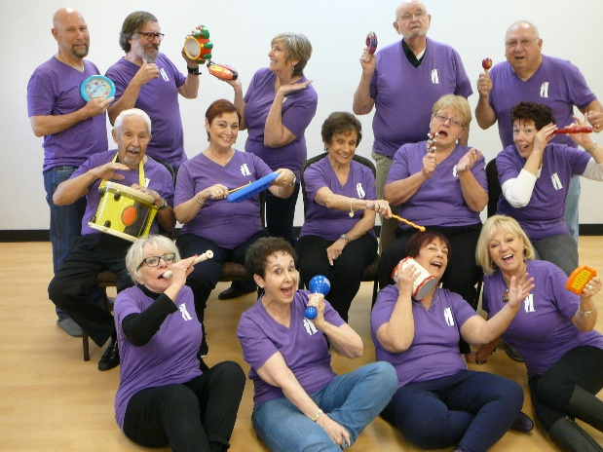
ImproVables performing Jan. 5
By Andrea Hummel
The ImproVables, SLCT's own improvisation troupe, will be performing January 5 at Oakwood Country Club. Tickets are available at the concierge desk in Oakwood for $25 which includes dinner and a show. All seats are reserved. Last year's show was sold out, so purchasing tickets early is advisable.
"This is the fourth time we've performed at Oakwood," commented one of the ImproVables. "It's always a great evening and we're really looking forward to it."
The menu includes Caesar salad with rolls, chicken marsala, seasonal vegetables and brownie bites for dessert. Coffee and tea are included.
The cash bar will be 5 to 5:45; buffet, 5:45 to 6:30; show at 6:30.

Kick-off the New Year at SLCT’s January 11th General Meeting!
“Turning Over A New Leaf!” will be the theme of this fun event!
Enjoy a dramatic presentation by the talented and enthusiastic students of the Hamilton High School Theater Department!
What an exciting way to start the New Year!

Join us for the good times and camaraderie!
A half-hour social begins at 6:00 pm and the General Meeting starts at 6:30 pm in the San Tan Ballroom at Cottonwood Country Club!

DUES ARE DUE!!
Membership dues are now due for the 2018-2019 year! They are still only $20. What a bargain!

For only $20 you get to participate in all of the fun activities, events, parties and plays of the upcoming year. You get the satisfaction of helping to support the high school drama departments in the Chandler area. You also get to support our Children's Theatre as it performs for young students in elementary schools all around Chandler. You get the pleasure of maintaining and furthering appreciation of theatre arts in Sun Lakes and the surrounding communities.

You may give your check to our treasurer, Kathy Jones, at our January 11 general membership meeting. We certainly hope that you will attend that meeting! If you cannot, you may mail your check to:

Kathy Jones
26602 S. Dartford Dr.
Sun Lakes, AZ. 85248

Make checks payable to Sun Lakes Community Theatre.

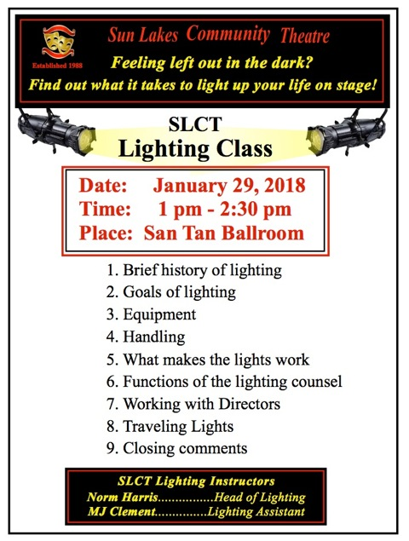

TWAS THREE MONTHS BEFORE THE OPENING DATE,
THINGS WERE GOING WELL,
YOU MIGHT EVEN SAY GREAT!
CAST AND CREW WERE ALL WORKING HARD,
OF COURSE, THE DIRECTORS KEPT SAYING, I’M ALREADY TIRED!
HOWEVER, WE KNOW THEY’RE ANXIOUS TO START,
SO GO OUT AND BUY YOUR TICKETS…AND DO YOUR PART!
MURDER AT THE TONY/LOU AWARDS SHOW
MARCH 20-24
DINNER/SHOW $36
OAKWOOD BALLROOM
TICKETS GO ON SALE FEBRUARY 13…10-1 OAKWOOD BALLROOM
AND ON-LINE 24/7 STARTING THE 13TH
CAST:
GINGER HENRY
JIM JANOWSKI
JO BIRLIN
ANDREA HUMMEL
MARILYN HOLT
CINDY DECKER
MARY VANDERGRIFF
RON BARNHILL
JOHN CRAWFORD
MICHAEL CARTER
GREG POSNIACK
PAT WOLFE
WITH ALL THIS TALENT, HOW CAN IT NOT BE A GREAT SHOW!

AUDITIONS
For
12 ANGRY JURORS

MARCH 28th, San Tan Ballroom, at 1pm

Call or email Howard Hummel for details and an audition packet. Everyone is welcome.
Runs Nov. 6th -10th Rehearsals start mid September
(541) 514-0000 - hhummel43@gmail

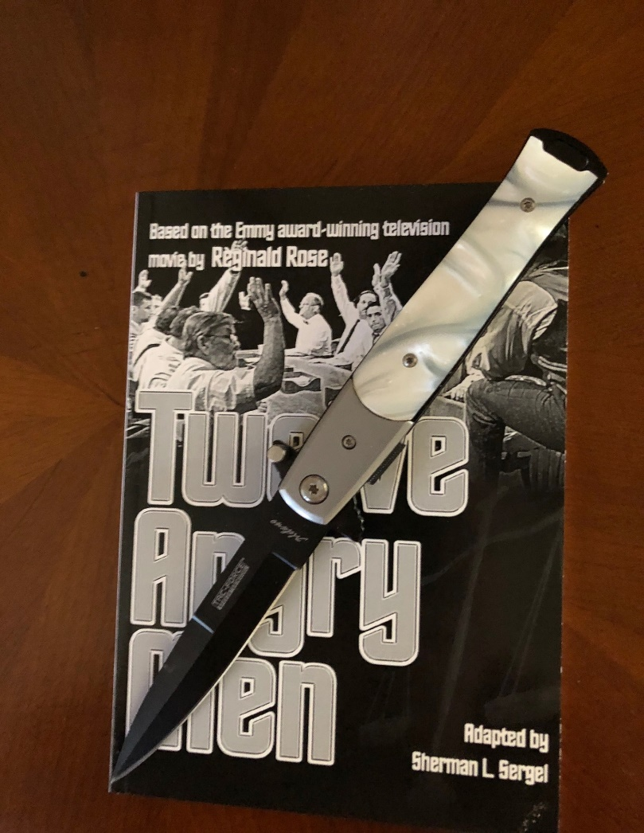
Intermediate Acting Class Coming Soon

What? Class for Intermediate level actors
When? Saturdays: 9am-noon : January 20, 27, February 3 2018
Where? Cottonwood Room A3
Who? Prerequisites: beginning acting class, or minor role in an SLCT production or previous acting experience outside Sun Lakes. Should be able to memorize.

How much? $5.00 covers cost of materials

Interested? Email Merrie Crawford : drjohn43@gmail.com
or call 480-802-7643

SUN LAKES COMMUNITY THEATRE’
GENERAL MEMBERSHIP MEETING
SAN TAN BALLROOM, COTTONWOOD
November 7, 2017 – 6:32 p.m.

CALL TO ORDER: Phyllis Novy, President called the meeting to order at 6:32 P.M. She asked if there were any guests or new members.

APPROVAL OF GENERAL MEMBERSHIP BOARD MINUTES: Motion made by Merrie Crawford and seconded by Barry Berger to approve the October 12, 2017 General Membership Minutes as written. Unanimously carried by the Membership.

FINANCIAL DATA: Phyllis reminded the Membership that the Financial Data is on the SLCT Website under General Archives.

ANNOUNCEMENTS:

HOLIDAY PARTY: The Holiday Party will be on December 12, 2017. Information about the party will be in the November Asides. The party will be held at Palo Verde. The cost is $25.00 and the menu is awesome. Entertainment will be by Jared Howe. Santa Claus will also be at the Holiday Party.

LOAD-IN/STRIKE FOR BEAU JEST: MJ asked for volunteers to help put up the black curtains on Monday November 13th, at 9:30 a.m. and taken down on Saturday November 18th, after the final performance.

HOUSE MANAGERS FOR BEAU JEST: Barry and Joan Berger are the House Managers for Beau Jest and need a few more volunteers to usher.

INTERMEDIATE ACTING CLASS: Merrie Crawford will teach an Intermediate Acting Class in the last two Saturdays in January and the first week in February, from 9:00 a.m. to 12:00 noon. Members will need to have some acting knowledge.

SPRING SHOW: Sandy Pallett’s Spring show will be Murder at the Tony Lou Awards. It is based on the Academy Awards. The play will be March 20-24, 2018. Auditions for the play will be held November 29, 2018 in the Oakwood Ballroom at 4:00 p.m. Scripts are available.

SCHOLARSHIPS/SCHOOL READERS: Each year the SLCT presents a Scholarship to a Chandler Senior who is majoring in drama. Applications have been given out to any Senior who is interested. Roger still needs a couple of volunteers to read for some of the Chandler Schools. Any donations for the Scholarships will be appreciated.

TECHNICAL: Rick Whitney needs volunteers for a Technical Committee for training classes.

SNIPPET ON BEAU JEST: Carol Horowitz said how thrilled she was at the progress that has been made on Beau Jest. Ticket sales are going well. Carol called for the entire cast of Beau Jest to come up and tell a little bit about their role in Beau Jest.

GUEST SPEAKER: Phyllis turned the meeting over to Sandy Pallett, from the Program Committee to introduce the guest speaker, Dave Specht. Dave is the owner of Improv Mania located in Chandler. Dave broke down why people laugh at comedy and offered to teach a workshop.

FALL SHOW 2018: Howard Hummel will be Directing the fall show “12 Angry Jurors”.

ADJOURNMENT: The meeting was adjourned at 7:59 p.m.

Sun Lakes Community Theatre Calendar May 2017 – April 2018
ImproVables | Jan. 5, 2018 | Oakwood Country Club
General Membership Meeting | Jan. 11, 2018, 6:00 pm | San Tan Ballroom
Intermediate Acting Class | Jan. 20, 27, and Feb. 3, 2018  9:00 – noon | Cottonwood Rm A3
Lighting Class | Jan. 29, 2018, 1-2:30 pm | San Tan Ballroom
General Membership Meeting | Feb. 8, 2018, 6:00 pm | San Tan Ballroom
General Membership Meeting | March 8, 2018, 6:00 pm | San Tan Ballroom
“Tony Lou Awards” Spring Show | March 20, 2018 – March 24, 2018 | Oakwood
End of the Year Party | April 10, 2018 | Palo Verde, Restaurant
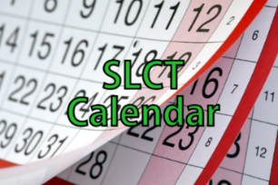
Attention All Committee Chairs:

I will be maintaining the on-line calendar on our website, www.slctinfo.com so we can have a central and accurate place to be able check on up-coming events and dates. Please email me, Barry Berger, at lumenprobb@yahoo.com with meeting, performance and any other dates you might feel are pertinent.
Barry Berger

Just a reminder that the SLCT membership can review the Financial Information on the SLCT Web Site. Type in www.slctinfo.com/generalarchives# to view the information.

SLCT is a Well-Wired Organization

Please visit the SLCT website at http://www.slctinfo.com/. It has information on upcoming productions, club history, past productions, photo slideshows, and much more. It even has a Resources page full of links to job descriptions of all SLCT roles, our bylaws, and other important information. It also has a button on the home page to connect you to our Facebook account and a button that points to an up-to-date calendar of scheduled SLCT events. If you have ever had a question about anything in SLCT, this is the place to go. See you there.

Jim Nielsen

Sun Lakes Community Theatre Board
Phyllis Novy  President | Jim Janowski  Vice President | Barry Berger  Secretary
480-895-5961 | 480-893-3525 | 480-883-2071
Rick Whitney  Technical Liaison | Carol Horowitz  Program, Education and Grants | Cindy Decker  Budget
425-232-6787 | 480-895-0236 | 515-770-7974
Kathy Jones  Treasurer  (non-voting member) | Dennis Dannehl  Publicity | Sandy Pallett  Past President  (non-voting member)
480-883-7471 | 281-224-7724 | 480-926-6954

Other Important Roles
Roxanne Banta  Mentoring Program Chairman | Michael Carter  Play Reading Chairman | Roger Edmonds  School Liaison
480-899-5696 | 480-895-1026 | 480-261-9957
Mary VanderGriff  Hospitality Committee Chairman | Jim Nielsen  Web Master and Ticket Sales | Sonja White  Asides
812-607-0412 | 602-717-8830 | 480-895-1986

